The 2008 Colonel Bengt Ljungquist
Memorial Championships

Method:
Horse/rider teams qualify by riding in designated BLM qualifying classes at participating competitions. Qualified horse/rider teams will then compete at the Finals.

Awards:
Prize money for places 1-3; Ribbons for places 1-8. Separate ribbons will be awarded to Junior/Young riders in a level if at least four Junior/Young Riders compete at the Finals.

Qualifying rules:
- A horse/rider team qualifies as a team, and only the same team may compete at the Finals.
- The rider must be a member of a participating GMO dressage association at the time of qualification.
- To be eligible to compete in the Finals in a given level, a horse must not have been shown before Oct. 23, 2008 in any test two levels above that level in shows recognized by the USEF, the FEI or any other National Federation. Exception: Riders who have never shown two levels above their Finals level may ride experienced horses.
- The rider is responsible for submitting a form as proof of qualification to the Championships Secretary as soon as possible after the qualifying ride. (Qualification Form available from Bettina Longaker, email address on following page and on www.CBLM.org.) A first-class postage stamp must be sent with the form, unless you include your email address. No rider will qualify until the Secretary receives a properly filled-out qualification form. The Secretary will confirm qualification by a qualification list on the official CBLM website.
- Competitions may not charge extra fees for qualifying rides.
- ANY class offered that is a CBLM test will be designated as a qualifying class.
- Only those competitions listed will be used as qualifying competitions. Over a period of four days or less, no more than two qualifying competitions may be held at the same location.
- Winning horse/rider teams at the Finals will be ineligible to compete at the same level in succeeding years, except for Intermediate II, Grand Prix, Grand Prix Freestyle, and Pas de Deux.
- The last date to qualify for the 2008 Finals is September 21, 2008.

Qualification Requirements:

USEF levels:
- The horse/rider team must achieve the following minimum percentages (qualifying tests to be used are indicated):
Training Level Test 3 65% (Seniors) 63% (Juniors/YR)
First Level Test 3 62% (Seniors) 60% (Juniors/YR)
Second Level Test 3* 62% (Seniors) 60% (Juniors/YR)
Third Level Test 2** 62% (Seniors) 60% (Juniors/YR)
Fourth Level Test 2*** 62% (Seniors) 60% (Juniors/YR)
- FEI levels: A horse/rider team must achieve the following minimum score in any FEI class at a qualifying show (National and CDI); FEI TOC classes may be used.
Prix St. Georges***** 60% (Seniors) 58% (Juniors/YR)
Intermediate I 60% 58% (Juniors/YR)
Intermediate II 60%
Grand Prix 60%
Musical Freestyles: The Qualifying score is 65%. At the Finals, there will be six freestyles. 1) First Level; 2) Second Level; 3) Third Level****; 4) Fourth Level******; 3) Intermediate I; 4) Grand Prix; 5) Pas de Deux. Any type of freestyle class will be accepted, including GAIG/USDF qualifying classes, USDF or FEI musical freestyles, or CDI freestyles.

* - FEI Pony Test may be ridden by Juniors to qualify at 2nd level; they will ride 2nd Level Test 3 in the Finals
** - FEI Junior Team Test may be ridden by Juniors to qualify at 3rd level; they will ride 3rd Level Test 2 in the Finals
*** - FEI Junior Individual & FEI Young Rider Team tests may be ridden by Juniors or Young riders respectively to qualify at 4th level; they will ride 4th Level Test 2 in the Finals
**** - FEI Junior Freestyle may be ridden by Juniors to qualify for the 3rd MFS; they will ride the 3rd MFS in the Finals
***** - FEI Young Rider Individual test may be ridden by Young Riders to qualify for Prix St Georges; they will ride PSG
****** - FEI Young Rider Freestyle may be ridden by Young Riders to qualify for 4th Level MFS; they will ride 4th MFS in the Finals

Rules Governing the Finals
- The same tests used to qualify will be used in the Finals, except the FEI Pony, Junior & Young Rider tests listed above.
- The tests must be ridden from memory and without whips.
- Entries for the Finals classes should be sent to the Finals Entry Secretary.
- A horse/rider team may qualify at more than one level but may compete at one level only at the Finals at the USEF levels; also, a horse may compete at only one USEF Level Final but may compete in an adjacent level freestyle Final. A horse/rider team may compete at two adjacent FEI levels at the Finals, but not in both Fourth Level and Prix St Georges.
- During the entire Finals competition, no horse entered in a Ljungquist Final may be ridden by anyone other than the rider entered in the Final on that horse.
- Both the Training Level Final and the First Level Final for senior riders will consist of two divisions: a) riders who have not competed at Third Level at an USEF recognized show before Oct. 23, 2008, and b) riders who have competed at Third Level at an USEF recognized show before Oct. 23, 2008.
7. Second through Third levels for senior riders will consist of two divisions: a) riders who have not competed at or above
the FEI Prix St. Georges level or in any of the FEI Young Rider levels at an USEF recognized show before Oct. 23, 2008, and b) riders who have competed at or above the FEI Prix St. Georges level or in any of the FEI Young Rider levels at an USEF recognized show before Oct. 23, 2008.
8. Fourth level for senior riders will consist of two divisions: a) riders who have not competed at or above the FEI Intermediaire I level at an USEF recognized show before Oct. 23, 2008, and b) riders who have competed at or above the FEI Intermediaire I level at an USEF recognized show before Oct. 23, 2008.
9. Prix St Georges level for senior riders will consist of two divisions: a) riders who have not competed at or above the FEI Intermediaire II level at an USEF recognized show before Oct. 23, 2008, and b) riders who have competed at or above the FEI Intermediaire II level at an USEF recognized show before Oct. 23, 2008.
10. The Championship competition is to be held within USDF Region 1 only.

BLM Website: http://www.cblm.org

To get a qualification form, check the website or send a self-addressed, stamped envelope to:
Bettina Longaker, Championship Coordinator
vadvirag8@gmail.com
8246 Open Gate Rd Gordonsville, VA 22942

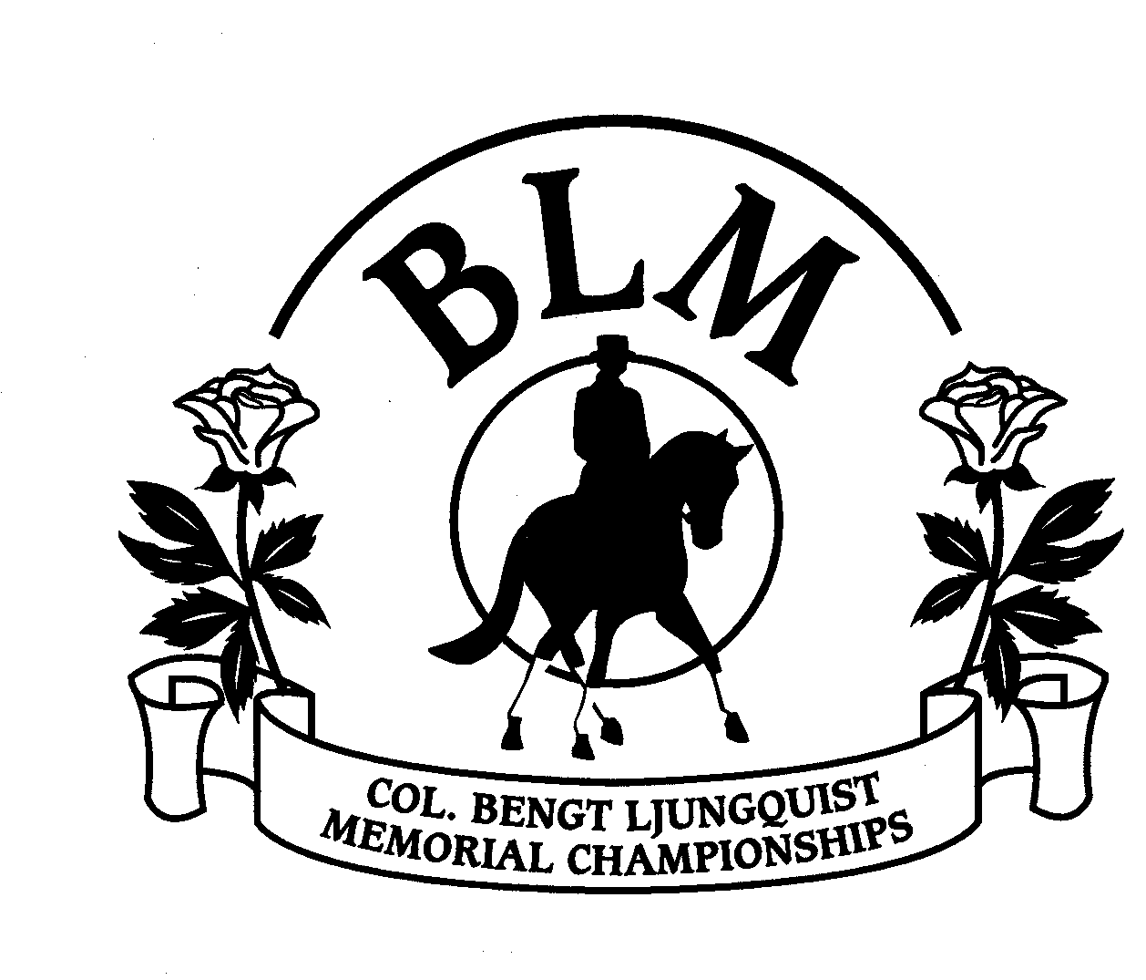
26th Annual Col. Bengt Ljungquist Memorial Championship Finals
Virginia Horse Center, Lexington, VA
October 23-26, 2008

Qualifying & Finals Secretary:
Bettina Longaker
8246 Open Gate Rd
Gordonsville VA 22942
e: vadvirag8@gmail.com
p: 540-832-7611
f: 540-832-5147

Participating Organizations
Carl Asmis Memorial DA, Commonwealth DCTA, Connecticut DA, Delaware Valley CTA, East Coast Regional DA, Eastern States DCTA, Garden State DS, Houston Dressage Society, International Equestrian Org., Lehigh Valley DA, Maryland DA, North Carolina DCTA, Orange County DA, Oley Valley CTA, Potomac Valley DA, South Carolina DCTA, Virginia DA, Western Pennsylvania DA

